**Bug Report**

**Reporter:** Dinesh Gopal

**Assignee:** Developer

**Product:** LumiraDXrest_api_demo

**Version:**  0.1

**Component:** Blog categories

**Environment:** TEST

**Platform:** PC

**Operating system:** Windows

**Priority: High**

**Severity:** Majore

**Status:** open

**Description:**

**Summary**

Verification of Create Category Using Post Service and retrieve created category using GET Service with DB validation.

The main purpose of this test is to verify, Category should be created using POST Service and the Created Category should be retrieve using GET Service

**EXPECTED RESULT:**

Category should be created using POST Service and Created Category should be retrieve using GET Service

**ACTUAL REULST:**

Category is created but the first character of attribute name got trimmed while storing in DB

Additional Info:

Source URL:<https://github.com/amaccormack-lumira/rest_api_demo>

Environment URL: <http://localhost:8888/api/#/>

Authentication: No authentication

**Test Evidence with steps to Reproduce:**

**Step 1: Creating Category using POST Service:**

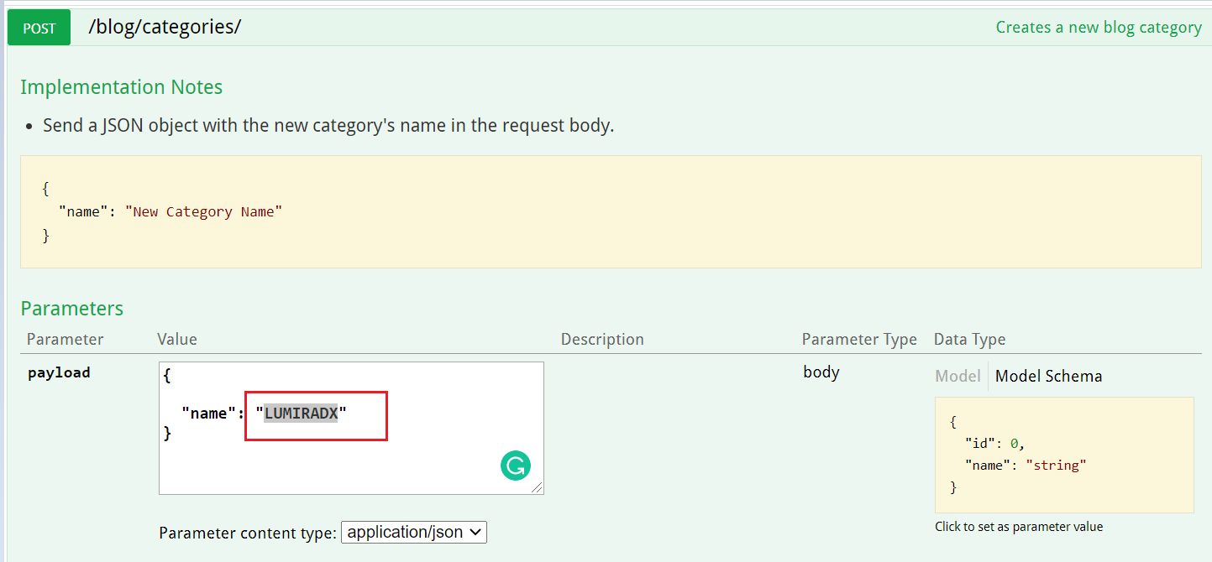

**Step 2 :Validating Data in DB**

**Connected SQLite with SOAPUI JDBC**

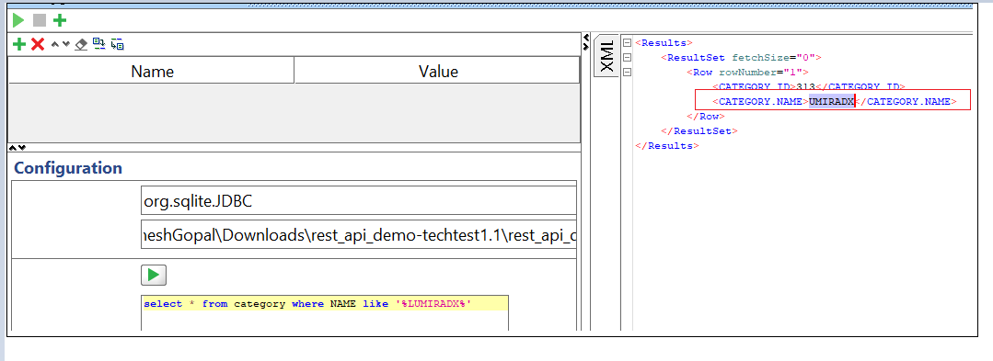

**Step 3:Retrieve Data using GET Service:**

